**For Immediate Release**

**Specialist printer creates ultra-realistic building wrap for Somerset House**

*London, UK; 8 January, 2020* - The iconic Neoclassical façade of Somerset House is instantly recognizable overlooking the South side of the Thames. And while the building is currently undergoing some restoration work, you may not have noticed thanks to [the ultra-realistic building wrap](https://projectprintmanagement.co.uk/ppm-large-format-print-projects/creative-scaffold-wrap-for-somerset-house/) that covers the construction work beneath.

The man behind this impressive faux façade says it’s been one of his most challenging jobs to date, involving countless hours of photo-editing, printing and installation by skilled professionals.

“This type of wrap is called a trompe L’oeil building wraps and they are somewhat of a specialised craft,” explains [Project Print Management (PPM)](https://projectprintmanagement.co.uk/) owner and creator, Justin Murray, “The process begins with a team of engineers and designers collecting accurate measurements and photos of the building façade, which are then carefully edited to create the perfect realistic perspective, colour and scale. A framework is then built over the building scaffolding that will hold the printed wrap exactly in place to create the optical illusion during the construction work. Our team then coordinates a skilled specialist rope access team to install the enormous print on the frame.”

The building wrap was digitally printed on 5-meter-wide format printer using UV ink technology onto Verseidag mesh PVC banner material, which can let the wind pass through.

These types of facade building wraps are often used when historical buildings are undergoing refurbishment or maintenance work. Since these buildings are often visited by tourists, it’s important they maintain their characteristic visual aesthetic, so the building wraps cover up any unsightly scaffolding, making it almost invisible.

Somerset House is one such grade 1 listed building, open to the public and regularly hosting exhibitions and events throughout the year from ice-skating in the winter to the Film4 summer screenings, where the courtyard is transformed into a stunning open-air cinema, housing London’s largest open-air screen.

“Most of our work is on period buildings, and it’s always challenging to get our print to visually represent the actual building. This is the 'art' of the process - making it look like nothing's there,” says Murray.

He founded PPM in 2011 after leaving the print company he had started at age 19 and run for 18 years, deciding to become a specialist large-format creative print coordinator.

Almost 10 years on and Justin is still enjoying using his business experience and creative talents for a range of exciting large format printing challenges, including his specialty of trompe L’oeil building wraps.

“Lots of companies handle quite complex large-format print jobs, but not many do the kind of thing we specialise in at PPM,” enthuses Murray, who has created building wraps for clients including; The Monument to the Great Fire of London, Everton Football Club Stadium and the BNP Paribas building.

ENDS

For further information of PR enquiries please contact:

**PPM**

Suite 5, 21 Farncombe Street, Godalming, Surrey, GU7 3AY

Phone: 07810 751683

Email:  [justin.murray@projectprintmanagement.co.uk](mailto:justin.murray@projectprintmanagement.co.uk)

<https://projectprintmanagement.co.uk/>

[Facebook](https://www.facebook.com/ProjectPrintManagement) I [Instagram](https://www.instagram.com/projectprintmanagement/) I [Twitter](https://twitter.com/Project_Print)

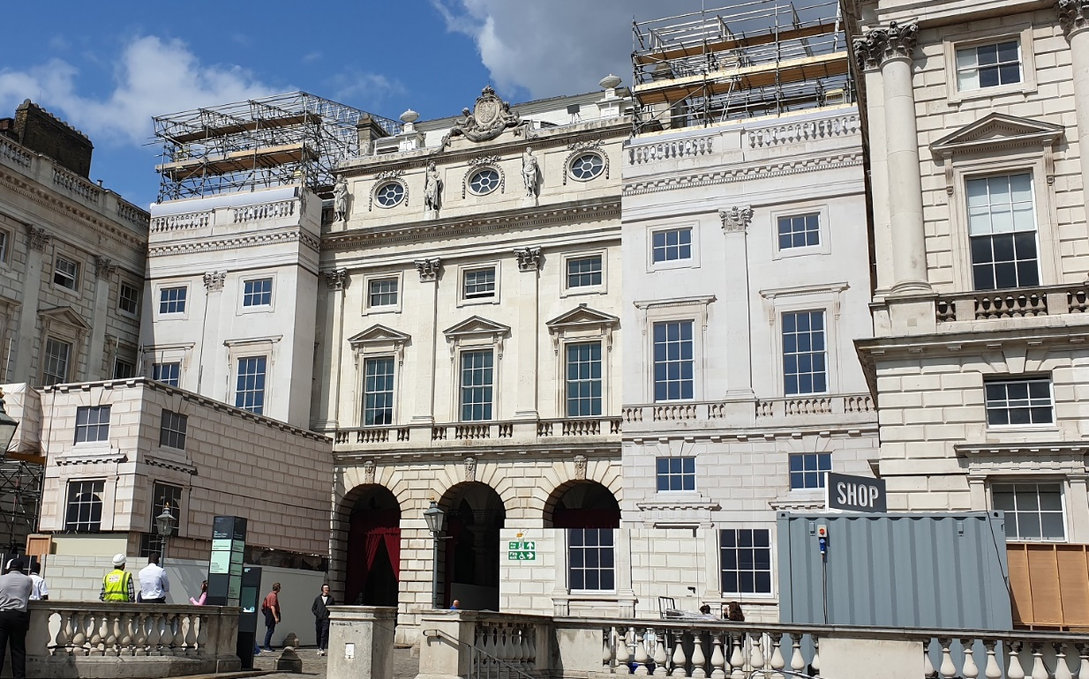

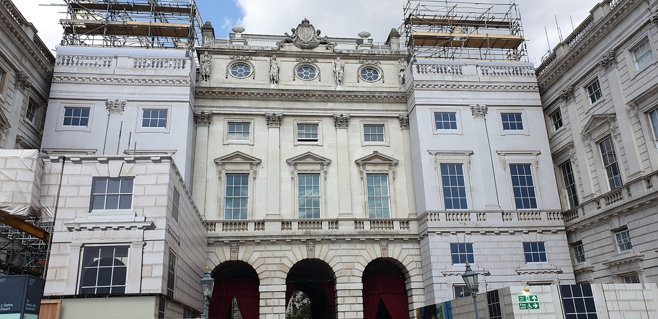

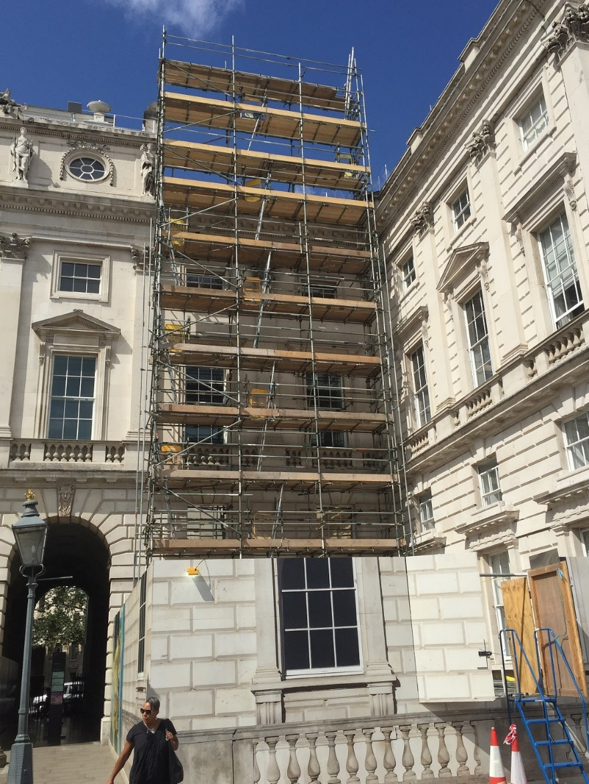

Before the building wrap installation